
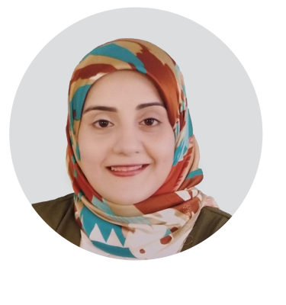
2015
- FACULTY OF MEDICINE
Bachelor of Medicine and Surgery, Assiut University with a (Very Good) grade.
EDUCATION


- Master Of Chest Diseases
Faculty of Medicine, Assuit University, a (very Good) grade.
5 Years
3 Years
- Chest diseases Assistant Lecturer
Faculty Of Medicine, Assuit University
- Chest diseases Resident Lecturer
Faculty Of Medicine, Assuit University
EXPERIENCE
- Interpretation of Pulmonary Function Tests.
- Analysis of Arterial Blood Gases.
- Thoracentesis.
- Ventilator management.
- Bronchoscopy and thoracoscopy.
- Medical History taking
- Critical thinking.
- Time Management.

- Problem Solving
SKILLS
B2
NATIVE

ARABIC
ENGLISH
LANGUAGES
+20 1090078962
azaabahaa270@
gmail.com
Assiut, Egypt

Adress:
Phone:
Email:
HOBBIES
READING
Jul-2020
- How to Write Research Protocol Workshop
Faculty Of Medicine
Jul-2020
- Writing Medical Reports Workshop
Faculty Of Medicine
Jul-2020
- Infection control
Faculty Of Medicine
- Evidence Based Medine
Faculty Of Medicine
Jul-2020
Mar-2017
- Pre-Employment Orientation Program
Faculty Of Medicine
Aug-2016
- Surgical Suturing
Assuit Medical Education Development And Training Center
April-2016
- Infection Control
Assuit Medical Education Development And Training Center
Jun-2016
- Quality Assurance
Assuit Medical Education Development And Training Center
Dec-2012
- Cardio-Pulmonary Resuscitation (C.P.R)
Assuit Medical Education Development And Training Center

2021
ASSISTANT LECTURER, DEPARTMENT OF CHEST DISEASES
BAHAA

AZAA
CONTACT

